BIG DATA CAPSTONE PROJECT REPORT

INDUSTRY: TRAVEL AND TRANSPORTATION

Topic: Taxi Driver Earnings Optimization

Name- Nikita Bharti

Roll No- 24MBMB18

1. Project Overview
The primary goal of this Big Data Capstone Project is to develop and implement data-driven strategies to maximize the earning potential and operational efficiency of taxi drivers. By leveraging a large dataset of historical taxi trip records, we analyze key factors—including demand patterns, route efficiency, and driving practices—that influence a driver's total income. The outcome is a scalable data pipeline and a suite of analytical models providing actionable insights for optimizing driver deployment and trip selection.

1.1 Core Objectives
- Develop a Scalable Pipeline: Process a large volume of trip data efficiently using Apache Spark in a Databricks environment.
- Identify High-Value Opportunities: Pinpoint temporal and spatial factors (hours, days, routes) that offer the highest earning potential.
- Build Predictive Models: Create a foundational model to accurately predict total trip earnings based on input features.
- Provide Actionable Insights: Deliver clear, data-backed recommendations to minimize idle time and maximize earnings per mile.

1.2 Data Preparation and Description

The project utilizes a 1-million-row synthetic dataset of New York City Yellow Taxi trips, loaded into a managed Delta table (yellow_taxi_cleaned) for fast, reliable access.
- Data Generation- Using Google Collab
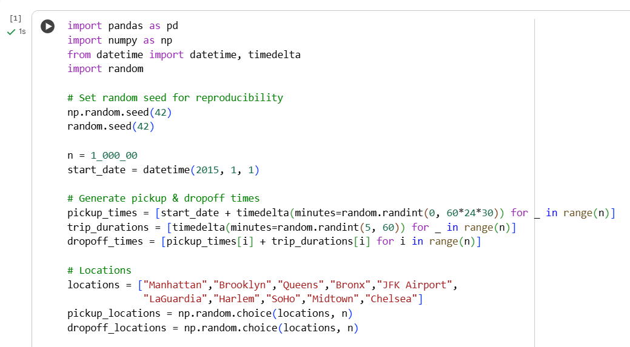

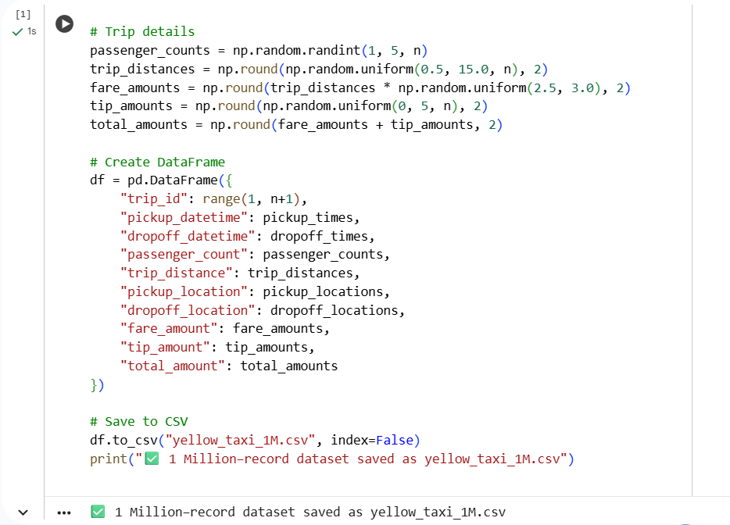

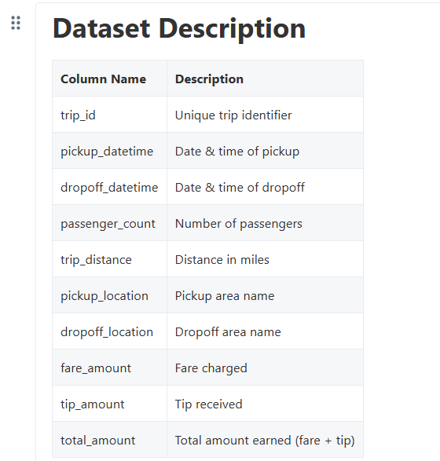

- Data Loading-MongoDB
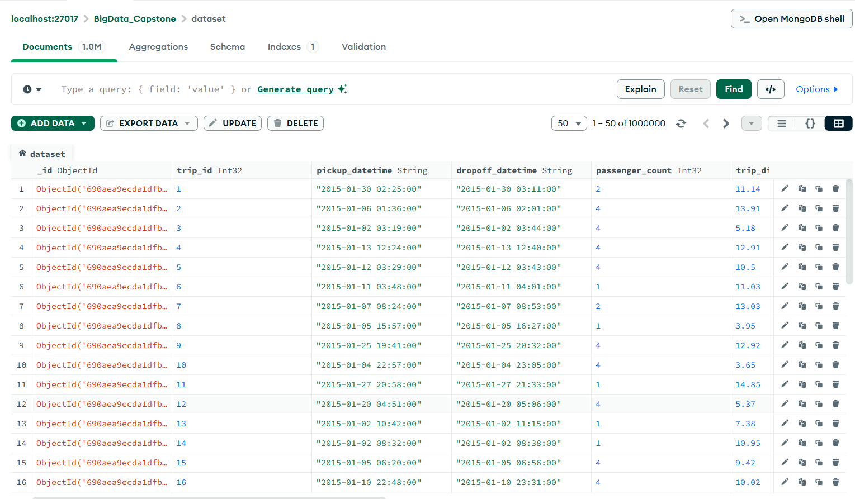

1.3 Methodology & Pipeline Structure
The project was executed through a structured Databricks notebook pipeline, ensuring data quality, feature richness, and model deployment scalability.
Pipeline Stages:
- Data Ingestion & Cleaning:
  - Load the raw 1M row dataset.
  - Perform Data Quality Checks (ensuring no nulls in key columns, verifying data types).
  - Filter invalid records (e.g., trips with zero distance, negative fare, or zero duration).
- Feature Engineering:
  - Calculate trip_duration_min (from pickup/dropoff timestamps).
  - Extract temporal features: hour, day_of_week, and month from pickup_datetime.
  - Calculate the core profitability metric: earnings_per_mile (total_amount / trip_distance).
  - Save the processed data as a persistent Delta table (yellow_taxi_cleaned).
- Analytical & Modeling Use Cases: Apply Spark SQL and Spark MLlib to address five distinct business questions (Use Cases) that directly impact driver income.
- Results & Conclusion: Summarize findings and provide data-backed strategic recommendations.

2. Use Case Descriptions, Objectives, and Implementation
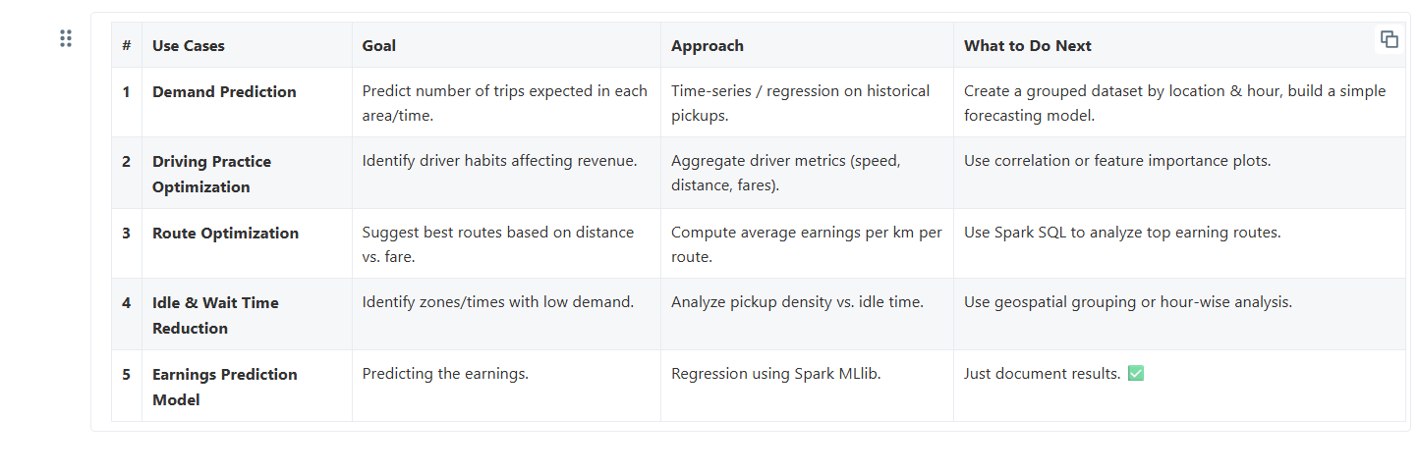
The project investigated five use cases, transitioning from descriptive analytics (Use Cases 2, 3, 5) to predictive modeling (Use Case 1) and operational efficiency (Use Case 4).

# | Use Case | Objective | Core Finding
1 | Earnings Prediction Model | To build a model that predicts the total_amount a driver will earn on a trip, allowing for better trip acceptance decisions. | Highly Predictable Revenue: The Linear Regression model achieved a low RMSE of 1.44, confirming that distance and temporal features (hour/day) are extremely reliable predictors of the final fare.
2 | Driving Practice Optimization | To definitively determine which variables (e.g., distance, tips) are the largest contributors to a driver's total revenue. | Distance is the Overwhelming Driver: Correlation analysis showed that trip_distance has an almost perfect positive correlation with total_amount ($r \approx 0.99$). Tips have negligible financial impact ($r \approx 0.13$).
3 | Route Optimization | To identify and rank the most profitable routes by calculating the metric earnings_per_km. | Long-Distance/Inter-Borough Value: The highest-value routes are typically long-haul trips connecting major areas, such as Manhattan $\to$ Queens, yielding the best revenue relative to the distance driven.
4 | Idle & Wait Time Reduction | To pinpoint specific low-demand time windows when drivers are most likely to be idle (not earning) to optimize shift and break scheduling. | Predictable Low-Demand Troughs: Demand analysis identified consistent low-volume periods around 5 AM (early morning) and 5 PM (17:00) (late afternoon). Drivers should schedule non-earning tasks during these times.
5 | Demand Prediction | To forecast the overall volume of trips expected based on time (hour and day), supporting strategic fleet and driver deployment. | Consistent Peak Windows: Trip volume peaks occur consistently across days during morning rush (7 AM, 11 AM) and evening hours (8 PM), establishing the prime working windows for maximizing income.

3. Tools and Technologies
Category | Tool/Technology | Role in Project
Big Data Processing | Apache Spark (PySpark) | Core engine for all data cleaning, feature engineering, analysis, and large-scale transformations.
Data Storage | Delta Lake / Databricks | Used to create managed, versioned, and optimized tables (yellow_taxi_cleaned) for fast analytical querying.
Machine Learning | Spark MLlib | Used to build and train the Linear Regression model for earnings prediction (Use Case 1).
Visualization | Matplotlib / Seaborn | Used for graphical analysis, such as correlation heatmaps and hourly demand trend plots.
Database | MongoDB (Initial Load) | Used for the initial loading and ingestion of the 1M row dataset before moving to Databricks/Delta Lake.

4. Results and Discussion
The project confirms that maximizing distance and minimizing idle time are the two fundamental levers for driver earnings optimization.
- Key Finding 1: Distance is Revenue
- Result: Correlation analysis revealed an almost perfect linear relationship between trip_distance and total_amount ($r \approx 0.99$). Conversely, the correlation between tip_amount and total_amount was minimal ($r \approx 0.13$).
- Discussion: The taxi's fare structure, which relies heavily on distance and time, makes revenue highly predictable and resistant to minor variables like tips. This strongly validates the strategy of focusing on efficiency metrics over customer service factors intended to increase tipping.
- Key Finding 2: Optimal Routes are Long-Distance
- Result: The calculation of earnings_per_km demonstrated that the highest value trips are typically long-haul or inter-borough, with Manhattan $\to$ Queens being a top-ranking profitable pair.
- Discussion: Drivers should be directed toward known high-density pickup zones that frequently generate these longer, more profitable trips to maximize their dollar return for each unit of distance driven.
- Key Finding 3: Idle Time Occurs at Predictable Hours
- Result: Hourly demand analysis , identified clear troughs in demand around 5 AM and surprisingly, 5 PM (17:00). The 7 AM, 11 AM, and 8 PM windows represent consistent peaks.
- Discussion: The afternoon low (5 PM) presents a significant opportunity for optimization. Drivers should be encouraged to schedule non-earning tasks (breaks, maintenance, administrative time) during the 5 AM and 5 PM windows to ensure they are on the road and actively generating revenue during the confirmed peak hours.

5. Conclusion and Key Learnings
This Big Data capstone project successfully implemented a scalable data pipeline and generated clear, actionable insights for taxi driver earnings optimization. The core conclusion is that optimization must focus on Trip Efficiency and Time Management.
- Key Learnings
- Big Data Scalability: Leveraging Spark and Delta Lake was essential to efficiently process the 1 million trip records, confirming the power of the technology stack for large-scale data analysis.
- Model Utility: The simplicity and low error rate of the Linear Regression model (RMSE $\approx$ 1.44) confirm that robust, actionable predictive tools can be built with minimal features, providing immediate value for real-time fare estimation.
- Actionable Strategy: The single most important strategy is to minimize time spent during low-demand periods (5 AM and 5 PM) and prioritize long-distance trips from high-value routes (e.g., Manhattan $\to$ Queens).
- Future Enhancements
- Advanced Modeling: Incorporate external features like real-time traffic data, weather patterns, and local event surge factors into the prediction model to achieve higher accuracy.
- Geospatial Clustering: Use advanced spatial algorithms (e.g., K-Means clustering on coordinates) to dynamically identify "hotspots" beyond pre-defined location names.
- Real-Time Dashboard: Create a live dashboard that displays predicted demand and recommended routes to drivers in real-time.

